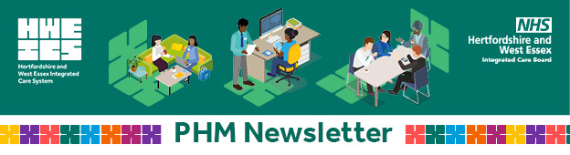

**Issue 4, June 2024**

Dear colleague,

Welcome to this issue of the Population Health Management (PHM) Newsletter where we share updates regarding the work taking place across our emerging Hertfordshire and West Essex (HWE) PHM community, in partnership with the health and care partners across the footprint, University of Hertfordshire and the voluntary sector.

1. **PHM Strategy and Offer**

Our first ever PHM Strategy can now be accessed on [our website](https://www.hertsandwestessex.ics.nhs.uk/our-work/population-health-management/#h-phm-strategy). The strategy outlines our vision and ambition for embedding a PHM approach within the local health system. This will enable more informed decisions and delivering care that most effectively and efficiently meets the needs of the population.

Our strategy is accompanied by our [PHM Offer](https://www.hertsandwestessex.ics.nhs.uk/our-work/population-health-management/#h-phm-offer-for-hertfordshire-and-west-essex) that details the support that is available to different parts of the system. The offer helps ensure that teams are supported to deliver their objectives using the PHM approach and achieve improved outcomes for the HWE population.

1. **PHM in action at ICB Staff Day**

Our own Dr Sam Williamson, Associate Medical Director, presented at the ICB Staff Day, explaining how we can better use information to understand our population and their health. He also highlighted some key points about our population, how these link to the priorities over the next few years and explained the ICB’s role in improving outcomes for our population.

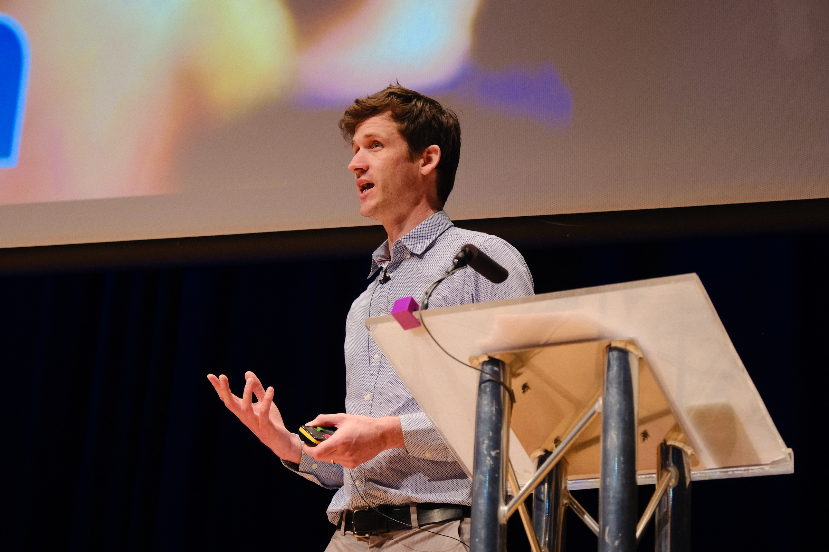

1. **Asthma insights pack is now available on the PHM website**



Did you know that asthma is the third most common morbidity in the country and also within Hertfordshire and west Essex?

Please visit our PHM website to access the latest [asthma insights pack](https://www.hertsandwestessex.ics.nhs.uk/wp-content/uploads/2024/04/Asthma-insights-pack.pdf) produced by the Medical Directorate. The pack outlines opportunities for our population through the analysis of the national and local data and supports programmes of work taking place across the system.

1. **Integrated Neighbourhood Team (INT) working**

Frailty and end of life have been identified as areas of priority for the ICB and the HCPs. We have been supporting INTs to identify their cohorts using specially developed GP clinical searches. The searches look at those who are living with frailty, end of life or end stage disease, adding layers of characteristics that might make individuals more likely to be admitted to the hospital. Alongside our primary care colleagues, our PHM team have visited INTs across all three HCP areas. We have also taken INTs through logic models to map out the outcomes they are trying to achieve along with the inputs and partners required to enable this. To support the evaluation process, a SNOMED code has been shared for the INTs to use which will be facilitated using the new data platform.

Thank you for taking the time to read our PHM Newsletter. Our next issue will be available in August. You can access previous newsletters [here](https://www.hertsandwestessex.ics.nhs.uk/our-work/population-health-management/phm-newsletters-and-case-studies/).